RETAIL SALES, ITEM & OUTLET PERFORMANCE ANALYSIS
1. Project Overview and Objective
To perform data insights to boost retail performance and drive revenue across store locations. By predicting product sales based on price, shelf placement, and product category, it helps managers stock the right inventory and position high-selling items on high-visibility shelves. Ultimately, clear data visualizations turn these complex patterns into actionable strategies, guiding decisions on where to open new stores and which products to highlight for maximum impact.

2. Data Sources
- Source Description and Timeline: Hugging Face - 22Years (1985-2009)
- Domain: Retail

3. Problem Statement
- To Calculate how much revenue a specific product will make at a given store location.
- To find out how price, product placement, and category affect sales.
- To Help managers stock the right items and place high-selling products on better shelves.
- To Use data insights to choose where to open new stores and which products to feature.
- To create meaningful visualizations that clearly explain the story behind the data

4. Attribute (Column /Features) Details:
Attribute Name | Data Type | Description
Item_Identifier | Categorical (String) | Unique ID assigned to each product.
Item_Weight | Numerical (Float) | Weight of the product.
Item_Fat_Content | Categorical (String) | Indicates whether the product is low fat or regular.
Item_Visibility | Numerical (Float) | Percentage of total display area allocated to the item in the store shelf.
Item_Type | Categorical (String) | Category of the product.
Item_MRP | Numerical (Float) | Maximum Retail Price of the product.
Outlet_Identifier | Categorical (String) | Unique ID assigned to each store location.
Outlet_Establishment_Year | Numerical (Integer) | Year the specific store was opened.
Outlet_Size | Categorical (String) | Ground area size of the store (Small, Medium, High).
Outlet_Location_Type | Categorical (String) | City tier rating of the store's location (Tier 1, Tier 2, Tier 3).
Outlet_Type | Categorical (String) | Classification of store format (Supermarket Type1, Type2, Type3, Grocery Store).
Item_Outlet_Sales | Numerical (Float) | Total sales revenue generated by the item at that particular outlet (Target Variable).

5. Tools & Technologies
- Python: Data cleaning.
- Power BI: Data modelling, DAX calculations, visualization, and interactive dashboard creation.

6. Data Pre-Processing (Python)
Tasks Performed:
Data Cleaning: Handle missing values (dropna(), fillna()) and remove duplicate records (drop_duplicates()).
Standardize Item_Fat_Content values
'LF': 'Low Fat',
'low fat': 'Low Fat',
'reg': 'Regular'

7. Data Modelling and DAX (Power BI)
- Calculated DAX Measures
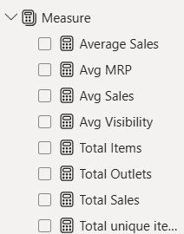

Average Sales = AVERAGE('Cleaned_Data'[Item_Outlet_Sales])
Avg MRP = AVERAGE('Cleaned_Data'[Item_MRP])
Avg Sales = AVERAGE('Cleaned_Data'[Item_Outlet_Sales])
Avg Visibility = AVERAGE('Cleaned_Data'[Item_Visibility])
Total Items = COUNTROWS('Cleaned_Data')
Total Outlets = DISTINCTCOUNT('Cleaned_Data'[Outlet_Identifier])
Total Sales = SUM('Cleaned_Data'[Item_Outlet_Sales])
Total unique items = DISTINCTCOUNT('Cleaned_Data'[Item_Identifier])

8. Analysis and Visualizations (Power BI)
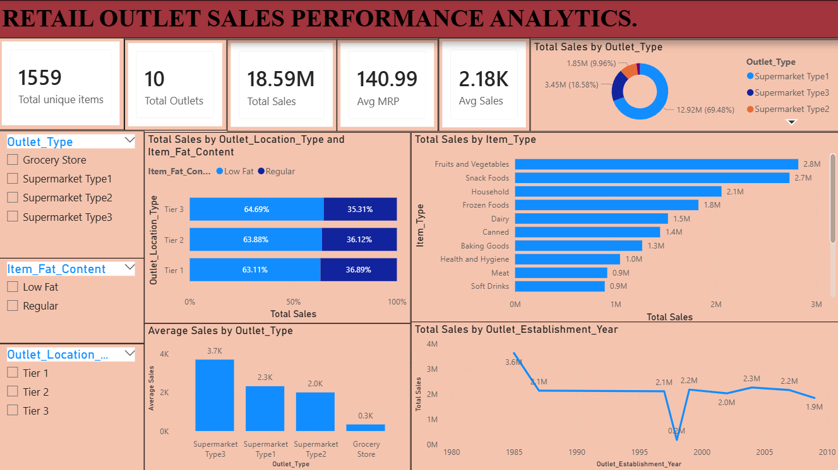
Based on my dashboard, here are the key details and summary metrics extracted from the charts
- Total Unique Items: 1,559
- Total Outlets: 10
- Total Sales: 18.59M
- Average MRP: 140.99
- Average Sales: 2.18K
Outlet Type Analysis
- Total Sales Share by Outlet Type:
  - Supermarket Type1: 12.92M
  - Supermarket Type3: 3.45M
  - Supermarket Type2: 1.85M
- Average Sales per Store Type:
  - Supermarket Type3: 3.7K
  - Supermarket Type1: 2.3K
  - Supermarket Type2: 2.0K
  - Grocery Store: 0.3K
3. Product Performance
- Top Selling Categories (Item Types):
  - Fruits and Vegetables: 2.8M
  - Snack Foods: 2.7M
  - Household: 2.1M
  - Frozen Foods: 1.8M
  - Dairy: 1.5M
- Fat Content across Outlet:
  - Low Fat Products: 64%
  - Regular Products: 36%

9. Insights & Conclusions:
1. Descriptive Analysis:
Total Revenue: Your stores generated 18.59M Crore in total sales across 10 outlets and 1,559 products.
Top Best-Sellers: Fruits & Vegetables (2.8 M) and Snack Foods (2.7 M) brought in the highest sales.
Customer Choice: Low Fat products made up 64% of total sales compared to Regular products 36%.
2. Diagnostic Analysis:
Store Format: Supermarket Type 3 made the most money per order because bigger supermarkets offer more variety and higher-priced items.
Store Size: Medium-sized stores performed better than large (High-sized) stores, showing that bigger space doesn't always mean higher sales.
Small Stores Struggled: Small Grocery Stores had very low sales because they carry fewer products and have limited space.
3. Predictive Analysis:
Healthy Product Demand: Sales for Low Fat items will continue to grow as customers focus more on health.
Medium Store Success: Opening Medium-sized supermarkets will consistently bring in higher sales than opening small grocery shops.
Popular Items: High demand for Fruits, Vegetables, and Snack Foods will remain steady throughout the year.
4. Prescriptive Analysis:
Stock Top Products: Keep high inventory for Fruits & Vegetables and Snack Foods so you never run out of stock.
Focus on Medium Supermarkets: Expand by opening more Medium-sized Supermarkets instead of small grocery stores.
Promote Low Fat Items: Give better shelf display to Low Fat items to boost revenue further.
Fix Small Stores: Add special discounts or popular everyday items to small grocery stores to increase their sales.

10. Conclusions
The dashboard shows that product price (Item MRP) and store type (Outlet Type) have the biggest effect on overall sales.
Placing items where customers can easily see them clearly helps boost total sales in every store.
Bring in customer ratings and reviews to see how product satisfaction affects overall sales.
Add inventory data to monitor stock levels and prevent items from going out of stock.
Track how special offers, seasonal sales, and store discounts impact total revenue.
Using sales predictions helps store managers pick the right items to stock instead of relying on pure guesswork.
Showing both actual past sales and expected future sales in one place gives leaders a quick, clear view of business performance.

